Assistive Technology Device
Jaclyn Jerse
Touro University Nevada

Diagnosis
Adhesive capsulitis also referred to as frozen shoulder is a condition characterized by a painful progressive loss of active and passive range of glenohumeral joint movement (Mayo Clinic Staff, 2011). The etiology remains unknown, however theories suggest initial inflammation involves the synovial lining that forms fibrous bands between tissues and organs (Mayo Clinic Staff, 2011). Physicians are unsure why this affects some individuals rather than others, although research suggests it is more common in people who have recently experienced surgery or an arm fracture movement. Prolonged immobilization of the shoulder occurs in three stages as the joint capsule thickens and tightens, restricting movement (Mayo Clinic Staff, 2011). The initial painful phase lasts between 2 and 9 months approximately and is characterized by pain with any movement of the shoulder, limiting range of motion (Foster & O'Driscoll, 2010). As pain begins to diminish a loss of active and passive range of motion occurs in the stiffness phase, which lasts between 4 and 12 months (Foster & O'Driscoll, 2010). Finally, the thawing phase occurs and ROM improves, lasting up to 26 months (Foster & O'Driscoll, 2010).
Client of Interest
My client of interest when constructing my assistive device was my mother who was diagnosed with breast cancer with secondary complications leading to adhesive capsulitis. She was diagnosed with stage IIb breast cancer having a tumor larger than 2 centimeters as well as clusters of cancer cells found in the lymph nodes. Surgery consisted of a total mastectomy to remove the whole breast that had cancer as well as some lymph nodes under the arm. After the doctor removed all of the cancer, my mother was given chemotherapy followed by medication to reduce the risk of any potential cancer cells. As a result after reconstruction surgery, she developed adhesive capsulitis and was unable to elevate her dominant shoulder.
Before my mother was diagnosed with cancer, she was a full time wife and mother of three who required constant attention. Her roles subsided as her sickness progressed, but when her immune system strengthened she did not hesitate to fulfill the occupations needed for her family. Some of these activities consisted of driving her children to and from school, completing necessary errands around the community, and cooking meals for her family.
As I reflect back to this time, I remember my mother having difficulty with grooming, specifically when styling her hair. This was due to her inability to elevate her dominant arm without experiencing a significant amount of pain. My family had just moved to a new home before my mother’s illness took place, so it was essential for her to want to maintain her appearance while accomplishing tasks in the community. I remember helping my mother style her hair with a brush and a curling iron for over 6 consecutive months, until her pain diminished. She despised asking for assistance and wished she could style her hair independently, but at this time there was no device to help her accomplish this goal. My mother attended physical therapy, but was not given the resources or compensatory strategies to utilize outside of the clinic.
Literature Reviews
Current Frozen Shoulder Interventions
Frozen shoulder syndrome remains largely of unknown etiology as well as a consistent challenge when selecting the best evidence-based intervention (Foster & O'Driscoll 2010). A narrative review titled, “Current concepts in the conservative management of the frozen shoulder” by Rebecca Louise Foster and Marie-Luce O’Driscoll viewed existing studies focused on treatment of frozen shoulder syndrome from January 2000 to September 2009. Five databases were used to obtain information using search terms such as frozen shoulder, adhesive capsulitis, physiotherapy, physical therapy and rehabilitation (Foster & O'Driscoll 2010). These findings highlight optimal physiotherapy interventions that were utilized for patients with frozen shoulder syndrome.
Results showed that mobilization techniques were effective in improving shoulder range of motion and functional ability (Foster & O'Driscoll 2010). Physical therapists saw significance in treatment sessions that focused on using deep heat while stretching to increase mobility within the shoulder joint capsule. Supervised neglect revealed to be favorable over intense physiotherapy in achieving near pain free function at 24 months. This means that stretching and exercises would only be permitted until pain occurred and limited further movement. This narrative provided several treatment strategies for frozen shoulder however further research must be done to identify the best evidence-based universal intervention to treat clients with frozen shoulder syndrome (Foster & O'Driscoll 2010). All strategies are appropriate for client treatment, yet supervised neglect attained greater patient responsiveness and corresponds to the need for assistive technology. Individuals would require more treatment sessions to gain full shoulder recovery since clients would only push themselves until pain limits are reached.
Supervised Neglect versus Intensive
Supervised neglect is described as active exercise within a comfortable range of motion. This means that clients should avoid pushing past the pain barrier understanding the benefit that less is more. A study by Ronald L. Diercks and Martin Stevens titled “Gentle thawing of the frozen shoulder: A prospective study of supervised neglect versus intensive physical therapy in seventy-seven patients with frozen shoulder syndrome followed up for two years,” justified the benefits of supervised neglect. Researchers compared the effect of intensive rehabilitation treatment, which included passive stretching and manual mobilization, to supportive therapy, which exercised within the limits of pain or supervised neglect (Diercks & Stevens 2004). Seventy-seven patients were included in this prospective study diagnosed with similar cases of idiopathic frozen shoulder syndrome (Diercks & Stevens 2004). At the end of the observation period, 89% of patients treated with supervised neglect had normal or near-normal painless shoulder function. In contrast, only 63% of the group that received intensive physical therapy treatment reached a constant score of 80 or higher after 24 months. These results indicate that supervised neglect yielded better outcomes than intensive physical therapy and passive stretching in patients with frozen shoulder (Diercks & Stevens 2004).
Supervised neglect may require a longer time for recovery, but clients will feel at ease as pain is managed. Assistive technology would be important to introduce for these clients as their recovery time may extend longer. Opportunities to use assistive devices with shoulder limitations will only benefit the client through enhancing performance and maintaining independence. It is important to educate clients on the need for rehabilitation services while using assistive technology so injuries no longer progress. As the client continues rehabilitation treatment to regain shoulder mobility, compensatory strategies followed by adaptive equipment may increase function while home.
Activities of Daily Living
A study in the Journal of Biomechanics titled “Modified 3D scapular kinematic patterns for activities of daily living in painful shoulders with restricted mobility: A comparison with contralateral unaffected shoulders” researched shoulder conditions that limited range of motion and deterred self-care activities (Roren, Lefevre-Colau, Roby-Brami, Revel, Fermanian, Gautheron, Fayad, 2012). Shoulder conditions were compared by scapular kinematic patterns for patients with affected and contralateral non-affected shoulders during self-care activities of daily living (ADL).
This study compared 48 patients as they performed two ADL tasks: hair combing and back washing. Out of the 48 patients studied 11 had glenohumeral osteoarthritis, 20 had frozen shoulder, and 17 had rotator cuff tendinopathies (Roren et. al, 2012). 3D scapular rotations and humerothoracic elevation (HTE) of the affected and contralateral non-affected shoulders were recorded with use of a 6 degrees-of-freedom electromagnetic device (Roren et. al, 2012). The HTE of affected and non-affected shoulders were compared for each pathology group at rest and at the HTE used to perform the ADL: 30°, 45° and 60° of HTE for hair combing, and 30° of HTE for back washing (Roren et al., 2012).
Results showed that the mean peak HTE for hair combing was significantly lower for the affected shoulders than the non-affected shoulders. Mean scapular lateral rotation was significantly greater at each HTE degree for glenohumeral osteoarthritis and rotator cuff tendinopathies groups however the mean scapular posterior tilt was significantly lower at 30° of HTE for the frozen shoulder group (Roren et al., 2012). For back washing, the mean peak HTE was lower for affected than non-affected shoulders for the frozen shoulder group in comparison to the glenohumeral osteoarthritis and rotator cuff tendinopathies groups (Roren et al., 2012).
This confirms that shoulder conditions affect one’s ability to participate independently and affectively in ADLs. The participants in this study with frozen shoulder suffered greater difficulty with hair combing and bathing in comparison to the individuals with glenohumeral osteoarthritis and rotator cuff tendinopathies. Clients with frozen shoulder showed a significant decrease in shoulder elevation of the affected side in comparison the contralateral side tested. This demonstrates that clients with frozen shoulder syndrome show significant decrease in range of motion in comparison to other shoulder conditions and would be excellent candidates for assistive devices.
Innovative Assistive Device
Reflecting on past experiences I decided to construct an adaptive device that my mom could have benefitted from. This furthered my search to frozen shoulder syndrome, finding out the commonalities of the prevalence of shoulder limitations amongst society. Evidence has shown that people experience the same problems my mother did with her inability to elevate her shoulder. The innovative assistive device I developed assists in hair styling allowing the client to curl their hair without shoulder elevation. This permits individuals to continue tasks of grooming independently while utilizing their dominant upper extremity affected by frozen shoulder.
The Extend Your Curl consists of a curling iron that has been adapted with an extension attached to the base of the curling iron as well as to the finger trigger. I constructed this device using a 1 inch X 24 inch precut PVC SCH40 pipe, 1 inch PVC FE adaptor, two ½ inch PVC couplings, ½ inch PVC slip cap, ½ X 24 inch precut PVC SCH40 pipe, and ¼ pint of clear PVC glue totaling $7.48 with tax (See Appendix B). I attached the pieces together with PVC glue and used a heat gun to angle PVC extension located on the trigger. This would guarantee the curling iron would have an ample amount of space to open and close and grasp the hair (See Appendix A). I removed the small rubber piece located on the trigger of the curling iron to fasten the PVC extension with a screw. Proper structural integrity of the screw would assure safety so the extension would not detach from the curling iron trigger. The second extension piece was secured with PVC glue to the base of the curling iron, which fit congruently. For aesthetic purposes, I added printed duct tape to the PVC pipe extension to portray a feminine chic appearance. The overall cost of my items, including the curling iron, totaled $27.84, well under the $60.00 item cost limit (See Appendix B).
With the curling iron extended, clients will utilize less range of motion and conserve a significant amount of energy when styling their hair. Individuals will eliminate elevation of their affected shoulder and will be able to independently style their hair with no assistance. Not only will the Extend Your Curl assist clients experiencing adhesive capsulitis, but will also be beneficial for clients with glenohumeral osteoarthritis, rotator cuff tendinopathies, and other shoulder limiting conditions. Diseases that require energy conservation techniques and strategies would benefit from this device to lessen energy expenditure and preserve energy for other occupations. Lastly, clients with thrombocytopenia-absent radius (TAR) syndrome may also find this device useful if curling their hair is a priority in their life. TAR syndrome is characterized by the absence of a radius bone in each forearm. If clients have the ability to utilize their hands for grasping, the Extend Your Curl will enhance their functional independence when grooming.
Enhancing Occupational Performance
My mother has survived and recovered from her illness, but remembers the struggles she faced. She acknowledged how beneficial a device like this would have been during her recovery and is happy to know there are several assistive devices that are available today to be utilized. If one is unable to complete ADLs effectively, it is highly likely that instrumental activities of daily living (IADL) will be just as difficult. Evidence shows that no therapeutic intervention is universally accepted as the most effective treatment for long term methods of care (Favejee, Huisstede, & Koes, 2011). Short term techniques have shown to be effective, but researchers need to continue to study long term treatment interventions for frozen shoulder. Until the etiology is completely understood, conflicting findings on pain, function and recovery lead practitioners with inconclusive answers when treating patients with frozen shoulder (Foster & O'Driscoll, 2010).
As a future occupational therapist, I would utilize the methods of assistive technology with interventions focused on supervised neglect to decrease the level of pain. Collaborating with the client to establish a strong therapeutic repertoire and being receptive to their level of pain may increase their level of participation in therapy sessions. Clients should continue rehabilitation treatment sessions to increase ROM and utilize modalities to enhance mobility. Assistive devices may be advised for the client to manage independence at home if shoulder mobility is limited. The Extend Your Curl device enhances performance without the constraints from necessary shoulder elevation when styling hair. Decreasing shoulder mobility when styling one’s hair will ease the needs of assistance from others. If techniques and devices are transferred over to other daily activities, individuals will maintain independence as they manage their shoulder condition.
The Extend Your Curl would have been a significant help for my mother after her breast cancer left her with secondary conditions of frozen shoulder syndrome. Her roles as a mother and wife quickly went back to normal and her appearance was important when completing daily tasks in the community. The psychosocial impact of breast cancer may lead to depression and negative body image perceptions. The act of grooming to make ones self-look good physically may enhance the client feelings internally. My mother does not like to place burdens on anyone or ask for help, and the times she does it is evident she is in pain. The Extend Your Curl would allow my mother to style her hair independently without experiencing any pain from shoulder elevation.
Occupational performance would also be increased with individuals who need to return back to work, but are unable to style their hair due to decreased shoulder mobility. If work obligations permit enhanced appearance, the Extend Your Curl would be an essential device to have to inhibit pain from constant shoulder elevation. This device targets a wide range of people in society today and exemplifies independence through modifications of hair styling performance.

Appendix A
Assistive Device Pictures
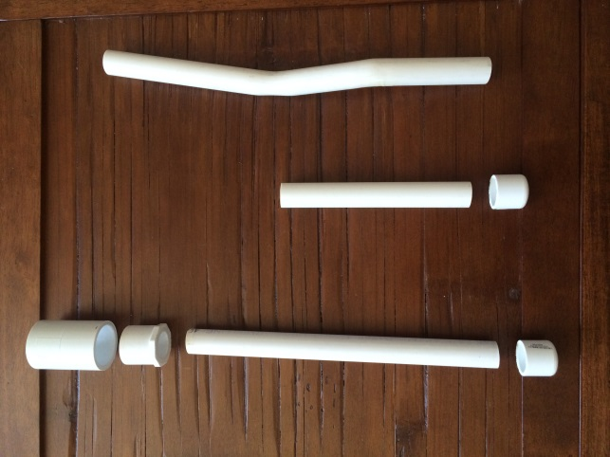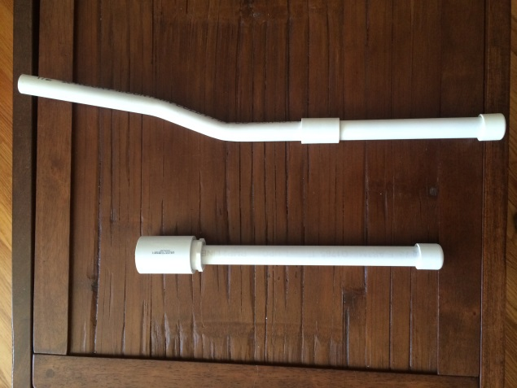

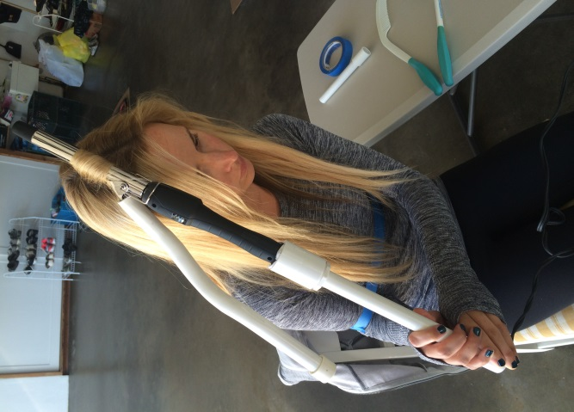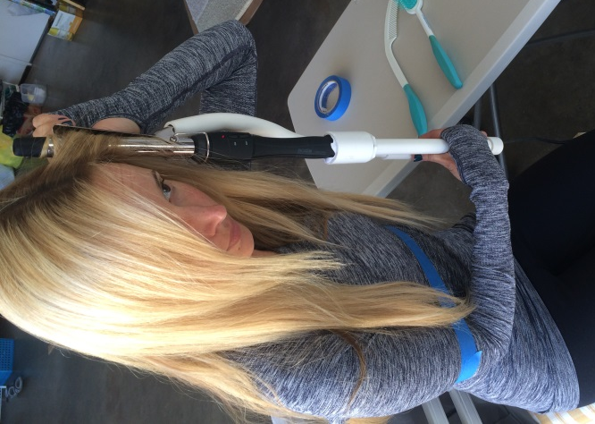

Appendix B
Assistive Device Pricing
Extend Your Curl:
1 X 24 inch precut PVC SCH40 pipe -------------$0.69
1 inch PVC FE adaptor-----------------------------$0.29
Two ½ inch PVC couplings------------------------$0.78
½ inch PVC slip cap---------------------------------$0.78
½ X 24 inch precut PVC SCH40 pipe-------------$1.49
¼ pt clear PVC glue---------------------------------$2.99
Total----------------------------------------$7.48 with tax

Additional Costs:
Extend Your Curl------------------------------------$7.48
Curling Iron-----------------------------------------$16.99
Aesthetic duct tape----------------------------------$3.37
Total of all items----------------------------------$27.84

References
Assis, M. R., Marx, A. G., Magna, L. A., & Ferrigno, I. V. (2013). Late morbidity in upper limb
function and quality of life in women after breast cancer surgery. Brazilian Journal Of Physical Therapy /Revista Brasileira De Fisioterapia, 17(3), 236-243. doi:10.1590/S1413-35552012005000088
Auriemma, D. (2008). The Frozen Shoulder Workbook. Physical & Occupational Therapy In
Geriatrics, 26(4), 73-74. doi:10.1080/02703180801964145
Diercks, R., & Stevens, M. (2004). Gentle thawing of the frozen shoulder: a prospective study of
supervised neglect versus intensive physical therapy in seventy-seven patients with frozen shoulder syndrome followed up for two years. Journal Of Shoulder And Elbow Surgery / American Shoulder And Elbow Surgeons ... [Et Al.], 13(5), 499-502.
Favejee, M., Huisstede, B., & Koes, B. (2011). Frozen shoulder: the effectiveness of
conservative and surgical interventions—systematic review. British Journal Of Sports
Medicine, 45(1), 49-56.
Foster, R., & O'Driscoll, M. (2010). Current concepts in the conservative management of the
frozen shoulder. Physical Therapy Reviews, 15(5), 399-404. doi:10.1179/174328810X12786297204710
Ingram-Rice, B. (2000). Occupational therapy perspective... frozen shoulder. Journal Of
Bodywork & Movement Therapies, 4(1), 20-26.
Mayo Clinic Staff. (2011). Frozen Shoulder. Diseases and Conditions. Retrieved May 16, 2014,
from http://www.mayoclinic.org/diseases-conditions/frozen-shoulder/basics/definition/con-20022510
Roren, A., Lefevre-Colau, M., Roby-Brami, A., Revel, M., Fermanian, J., Gautheron, V., . . .
Fayad, F. (2012). Modified 3D scapular kinematic patterns for activities of daily living in painful shoulders with restricted mobility: A comparison with contralateral unaffected shoulders. Journal of Biomechanics, 45(7), 1305-11. doi:http://dx.doi.org/10.1016/j.jbiomech.2012.01.027
Soviero, F., Gucciardi, S., & Geraci, A. (2008). THE FROZEN SHOULDER: UNKNOWN
AND KNOWN KNOWNS. (English). Capsula Eburnea, 31-14.

